The Step Up projects

March 2018

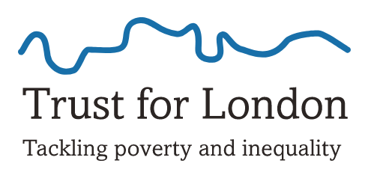
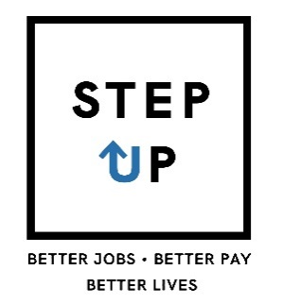

Published by National Learning and Work Institute (England and Wales)
21 De Montfort Street, Leicester LE1 7GE
Company registration no. 2603322 | Charity registration no. 1002775

Learning and Work Institute is a new independent policy and research organisation dedicated to lifelong learning, full employment and inclusion.
We research what works, develop new ways of thinking and implement new approaches. Working with partners, we transform people’s experiences of learning and employment. What we do benefits individuals, families, communities and the wider economy.
We bring together over 90 years of combined history and heritage from the ‘National Institute of Adult Continuing Education’ and the ‘Centre for Economic & Social Inclusion’.
www.learningandwork.org.uk @LearnWorkUK @LearnWorkCymru (Wales)
All rights reserved. No reproduction, copy or transmission of this publication may be made without the written permission of the publishers, save in accordance with the provisions of the Copyright, Designs and Patents Act 1988, or under the terms of any licence permitting limited copying issued by the Copyright Licensing Agency.

CONTENTS
Introduction 5
The Creative Society 7
Step Up support model 7
Participant characteristics and barriers 8
Key strengths 9
Key learning 9
High Trees 11
Step Up support model 11
Participant characteristics and barriers 12
Key strengths 13
Key learning 14
Indoamerican Refugee and Migrant Organisation 15
Step Up support model 15
Participant characteristics and barriers 16
Key strengths 17
Key learning 18
The Springboard Charity 19
Step Up support model 19
Participant characteristics and barriers 20
Key strengths 21
Key learning 21
Thames Reach 23
Step Up support model 23
Participant characteristics and barriers 24
Key strengths 25
Key learning 26
Women Like Us 27
Step Up support model 27
Participant characteristics and barriers 28
Key strengths 29
Key learning 29

Introduction
Step Up is a pilot initiative, designed and commissioned by Trust for London and the Walcot Foundation, in partnership with Learning and Work Institute, which aimed to test and learn from new approaches to supporting earnings progression among low paid Londoners. The programme was delivered from October 2015, and has recently been extended for an additional year, due to complete in September 2018.
Step Up was delivered by six voluntary sector organisations, each of which designed a distinct support model and/or targeted a specific group of low-paid workers – see Box 1. This report presents the headline findings and learning points for each of the six providers. The main report, published alongside this, summarises findings and learning across the programme.
The target outcomes for Step Up were:
1) Higher hourly wages and weekly earnings
- An increase in hourly wage rate by more than 10%
- An increase in wage rate to the level of the London Living Wage or above.
- An increase in weekly earnings (equivalent to 36 hours a week at the London Living Wage or above; or 16 hours if a lone parent).
2) Improved conditions, responsibility and skills
- Movement from a zero hour contract or temporary contract to a permanent contract
- Improved responsibility or job description.
Each Step Up provider delivered a distinct delivery model, tailored to their target group. However all projects included a specialist adviser or coach, who provided tailored, one-to-one support to participants, including:
- setting goals and developing action plans,
- identifying challenges and support needs,
- help with looking for additional or better work,
- practical support, and
- onward referral to wider services and partners, for example for training and skills development.
Other support activities delivered by providers included peer mentoring, group support sessions, and jobs brokerage.
Learning and Work Institute provided learning and evaluation support to Step Up. As this was a pilot, an emphasis was placed on learning from the initiative for future programme design, commissioning, delivery and evaluation.
Box 1: Step Up projects

The Creative Society
Supporting young people working in the creative & cultural sectors. Contact: Barbara Palczynski (barbara@thecreativesociety.co.uk)
High Trees Community Development Trust
Supporting the local community, in particular lone parents and people aged over 50. Contact: Grace English (Grace.English@High-trees.org)
Indoamerican Refugee and Migrant Organisation (IRMO)
Supporting Latin American workers, focusing on those working in cleaning. Contact: Patricia Cazenave (patricia.cazenave@irmo.org.uk)
The Springboard Charity
Supporting workers in the restaurant and hospitality sector. Contact: Peter Harrison PeterH@springboarduk.org.uk
Thames Reach
Working in partnership with Clean Slate to pilot digital engagement with low-paid workers. Contact: Alessy Beaver, step-up@thamesreach.org.uk, www.stepuplondon.co.uk
Women Like Us (part of the Timewise Foundation)
Supporting parents to progress in work, through enabling access to better paid part-time and flexible jobs. Contact: Poornima Kirloskar-Saini (Poornima.Kirloskar-Saini@womenlikeus.org.uk)
Funders
The Walcot Foundation – Teresa Priest (Teresa.Priest@Walcotfoundation.org.uk)
Trust for London - Austin TaylorLaybourn (Austin@trustforlondon.org.uk)
Learning and Evaluation partner
Learning and Work Institute – Kathryn Ray (kathryn.ray@learningandwork.org.uk)

The Creative Society
The Creative Society aims to support young people from disadvantaged backgrounds to access jobs in the creative and cultural sectors. Their work includes delivering employment and skills programmes as well as research and advocacy to promote fair access and opportunity in the creative sector.

Step Up support model
The Creative Society developed a model for Step Up based on one to one support with a careers coach, opportunities for participants to meet industry specialists and the provision of networking opportunities. It was delivered by one part time Creative Careers Coach and later additionally resourced by a second part time staff member. Support included:
- One to one coaching from a Creative Careers Coach, accessed by 90% of participants. The coach provided a wide range of support, including coaching to build confidence and motivation; employability based support; creative sector careers advice (including freelancing tips); and setting up meetings with industry specialists. Support was tailored to individual needs and aspirations and based on goal-setting.
- Industry specialist meetings were arranged for participants to gain knowledge about how to enter and advance in their chosen field from relevant sector experts.
- Networking opportunities were designed to help participants overcome the barriers to entering the creative sector through creating contacts and gaining networking skills to use in the future. These events also provided participants with the opportunity to meet together and collaborate on creative projects.
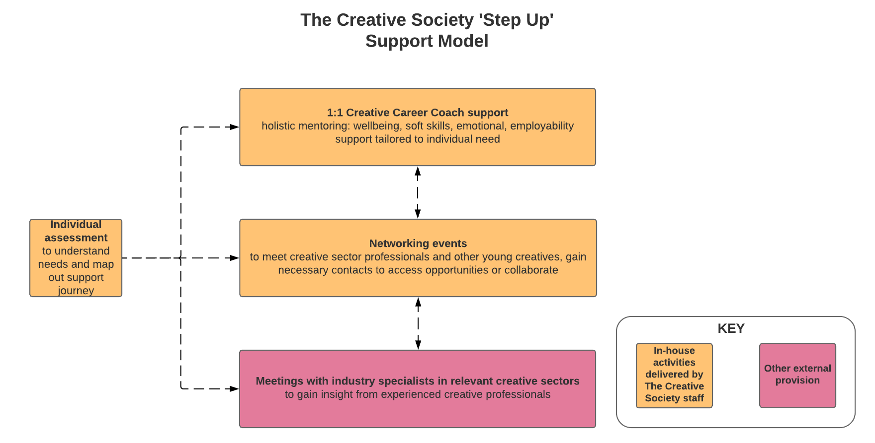
Step Up participants received an average of 7 hours of one to one support with the Creative Career Coach and 10 hours of support in total.

Participant characteristics and barriers
Of Creative Society’s 77 participants:
- 88% participants were aged between 18 and 30 and the remainder between 31 and 40.
- Participants were fairly evenly divided between male (57%) and female (42%) participants (with 1% gender neutral).
- Creative Society participants were more highly qualified than those with other Step Up providers, with over half (53%) holding a UK degree qualification or higher, and a further 18% qualified to A level/ level 3. However 18% were qualified only to level 1 or below. Very few (3%) were educated overseas.
Employment situation
- Of all Step Up providers, Creative Society had the lowest proportion of participants employed on a permanent contract (42%) and the highest proportion on a temporary zero hours contract (37%). 9% had no employment contract.
- The most common starting sectors were creative (30%), retail (18%) and hospitality (15%).
- 61% of participants wanted a career change when they joined Step Up.

Creative Society’s Step Up participants were highly qualified and unlikely to require external provision for skills needs. Their main barriers were specifically related to accessing the creative sector. These barriers included:
- A lack of creative sector contacts, which made it difficult to attain creative paid work or work experience. Consequently they could lack knowledge about what creative sector employers wanted in an employee.
- Loss of creative identity and confidence in creative ability. Participants with barriers to accessing the sector had to take (often) low paid, non creative employment. Over time, this eroded confidence in their creative ability or identities.
- Lack of time to access support. Individuals who worked long hours had less time to concentrate on applications, goal setting and accessing support. This was exacerbated for individuals working zero hours, freelancing or flexible contracts, who were less able to plan around their changing work commitments and often had to cancel support sessions for last minute work.
- Poor mental health and wellbeing. This was a significant barrier for participants who had lost confidence in their ability to access creative employment. Many did not have an official diagnosis, but suffered adverse effects on their confidence and motivation to pursue progression opportunities due to mental ill health.

Outcomes achieved
- 29 participants achieved an employment outcome (38% of all those enrolled).
- These were mostly new jobs (19 people), while 9 people secured an additional job, 5 people improved their contract, 3 improved their working hours and 2 were promoted.
- Of those who achieved a new job, 21% moved into the creative sector, 11% remained in the creative sector and 68% were not in the creative sector.
- Of those who achieved an additional job, 33% remained in the creative sector, 66% were in non-creative sectors and none were a move into the creative sector.
Programme targets:
- 7.8% of participants obtained a 10% increase in hourly wage
- 6.5% of participants obtained an hourly wage of LLW or above
- 6.5% of participants obtained the weekly earnings target (36 hours x LLW or 18 hrs if lone parent)
- 26% of participants who started on an insecure contract obtained a permanent contract.

Key strengths
- The Creative Careers Coach
The most important aspect of the support model was the one to one coaching, delivered by an adviser with an established career in the creative sector. This meant that she had good contacts in the sector and first-hand understanding which enabled her to provide the specialist support required. Participants valued having a mentor to advise them on how to progress in the creative industry based on first-hand experience.
- Links with creative sector employers
The creative sector is broad and encompasses several specialist fields. The Creative Society staff and trustees had a wide range of contacts within the sector, which enabled them to set up one to one meetings between participants and employers in a range of fields such as TV and film, theatre, dance, art and fashion. Participants received advice and gained a contact in their field of interest.
- User-led support model
Step Up support was tailored to individual needs based on a tailored action plan, which focused on setting goals, breaking these into manageable steps and progressing through them. The support model also evolved over time, for example networking events were developed in response to participants wanting an opportunity to practice their networking skills. Learning from Step Up is being used by Creative Society to develop a ‘Creative Jobs Studio’ offer for anyone interested in accessing, or progressing in, the creative sector.

Key learning
- Resourcing
The support was initially delivered with one adviser working 3 days a week. Adviser resource was increased to 4 days, including out of hours and telephone support, to ensure that participants could access one to one support around their working hours. This resource still proved to be limited for managing the caseload as well as other activities such as engaging new referral partners in order to maintain participant numbers.
- Mental health provision
Undiagnosed and/or unacknowledged mental health difficulties among participants, and difficulties accessing external support for this, meant that the Creative Coach role needed to include a significant element of counselling support. Together with a holistic support model, that focused on an individual’s creative capabilities rather than generic employability support, this tended to blur the boundaries of support and resulted in an intensive support model.
- Access to the Creative Sector may not produce positive earnings outcomes
Creative sector companies employ a small amount of people in comparison with other sectors and often have funding structures that make it difficult to forecast future staffing. Therefore jobs are often short term, freelance work rather than permanent roles. Such roles may not result in a weekly earnings increase initially, and for many participants, their definition of a ‘better job’ did not fit with the specified Step Up programme outcomes. This also impacted on the ability of the Creative Society to build in a job brokerage aspect to the support (though employers were engaged in other ways, such as through networking events).
Case study: Billy

Billy has been working in the creative industry as a writer and visual artist for several years. As well as his income increasing slightly, and having secured more regular work as a result of Step Up, Billy has gained direction, confidence and the practical skills needed to deal with the challenges of being self-employed, such as gaining knowledge and experience in negotiating contracts and fees, and asking for feedback after unsuccessful job interviews.
Billy found the opportunity to attend formal networking events especially beneficial as it gave him a chance to speak to potential employers, but also enjoyed the more informal networking opportunities with Creative Society peers, which he felt provided a useful platform to discuss the challenges and opportunities of working in the creative sector:
"I’m more comfortable with contracting money conversations, I know roughly what my fees should be now… you’re young and you get massively exploited on your fees”
“My robustness, loss of vulnerability, a sense of ease with things [is] totally to do with Creative Society… I feel massively more confident, they helped my mental situation a lot and to just meet people who are understanding is incredible. I know my direction more.”

High Trees
High Trees is an established community hub in Tulse Hill, Lambeth, which delivers a range of services to residents in the local community, focusing on employment, education and training support; children, young people and family services; and community engagement and development.

Step Up support model
High Trees developed a support model based on one to one personalised support from an adviser and access to a range of internal and external provision. For the majority of Step Up delivery, this support was delivered by two part-time advisers.
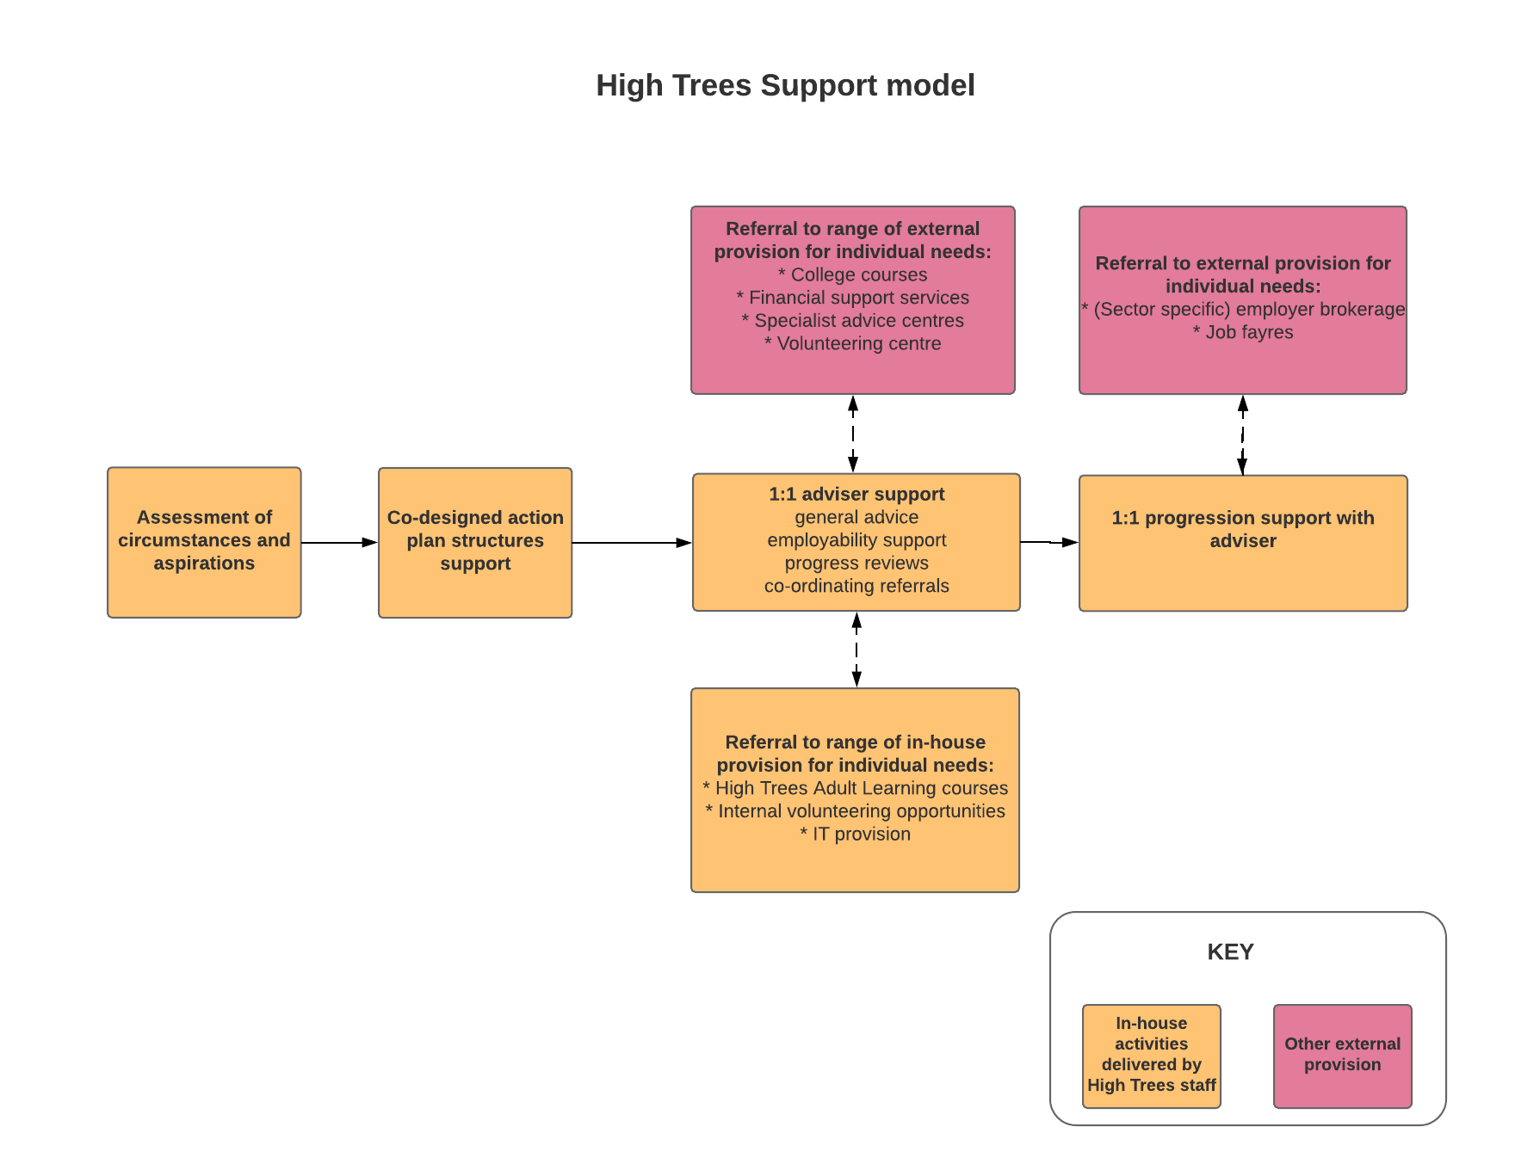
Each participant developed an action plan with their adviser, which structured the support and tailored it to individual needs, barriers and aspirations. Advisers provided a range of interventions including employability related advice and support (with CVs, job search, interview preparation and career advice), coaching, and advice with participants’ wider support needs.
Step Up participants received an average of 4 hours one to one support with an adviser and 12 hours of support in total.
Step Up participants could access a range of additional support services from High Trees, including community learning and accredited training courses, employment support, volunteering opportunities, work placements and access to centre facilities such as an internet café. Links with local organisations were also utilised to support a range of additional needs. Around a third of High Trees participants were referred to an external organisation – higher than for other Step Up providers. Partners included housing associations, colleges and advice organisations for issues such as financial health. Links with job brokerage services also provided job opportunities for participants.

Participant characteristics and barriers
Participant characteristics
Of High Trees’ 73 Step-Up participants:
- Three quarters were female
- Participants were spread across all age categories, with an average age of 42
- 17% had a disability, which was the highest proportion of all Step Up providers
- 88% lived in council rented accommodation, again the highest proportion among Step Up providers
- Participants had wide-ranging qualifications, including 14% educated to level 2, 14% to level 3 and 15% holding a UK degree. A further quarter had an overseas degree and 11% had no qualifications
- 46% of participants were lone parents
- Just under half (49%) of participants had English as a Second Language.
Employment situation
- The majority (58%) of High Trees participants were employed on a permanent contract when they started Step Up, but a sizeable proportion (33%) were on a temporary zero hours contract.
- The most common starting sectors were retail (22%), cleaning (21%), hospitality (15%), care (14%) and education (11%).
- 61% of High Trees participants wanted a career change when they joined the programme.
High Trees supported a wide range of low paid workers in their community who had a range of barriers to improving their earnings. These barriers included:
- Employability skills and knowledge including a lack of experience of job searching, formal applications and interview processes.
- Non-transferable qualifications, English language proficiency and digital skills barriers. These could be exacerbated by a lack of access to training due to limited financial resources or limited availability due to work and wider commitments. Non-transferable qualifications and a lack of relevant work experience could prevent progression into a preferred sector.
- A range of personal circumstances, such as caring responsibilities, physical and mental health, financial issues and housing pressures could impact on participants’ ability to progress in work. These circumstances could also affect their ability to attend support and reduced their likelihood of sustaining engagement with Step Up.
- Recent political uncertainties following the vote to leave the European Union resulted in some participants from the EU feeling unsure about the implications of this on their long-term future in London.
Outcomes achieved
- 29 participants (40% of all those enrolled) achieved an employment outcome: 22 participants achieved a new job, 2 found an additional job, 1 improved their contract and 5 participants secured a promotion.
- The largest positive sector changes were people becoming employed in Construction (+9%) and Local Government (+9%). The sectors that participants were leaving were cleaning (-8%) and health (-8%).
Programme targets
- 14% of participants achieved a 10% hourly wage increase
- 15% of participants obtained an hourly wage of LLW or above
- 14% of participants obtained the weekly earnings target (36 hours x LLW or 18 hours if a lone parent)
- 30% of participants who started on an insecure contract obtained a permanent contract.

Key strengths
- Range of outreach and engagement methods. High Trees were able to engage participants onto Step Up through their wider services, such as adult learning courses, centre facilities such as their internet café, and through their outreach activity, such as door knocking. This approach to engagement helped them to recruit participants who were hesitant to access Step Up support, but would engage with other activities and gain the confidence to access career progression support later.
- Community hub status. High Trees services (particularly adult education) were well known by local residents and referral partners. This provided them with good community links which could provide a wide range of support to address participant needs.
- Adviser relationship. Participants valued the coaching support received by advisers which was tailored to their needs and provided a range of employability based support when needed.

Key learning
- Not all partnerships were suitable for working residents. Partnerships with job brokerage services were less effective than anticipated because their support was orientated to the needs of unemployed residents. They tended to target entry level jobs in low paid sectors (primarily retail, hospitality and catering) and were not able to broker access to the wider range of sectors required by Step Up participants.
- Personal development needs required more support than skills based needs. Initial expectations were that participants’ needs would be heavily skills orientated. However, staff found that participants needed more support with soft skills, such as writing their CV and application forms, and personal development needs, rather than addressing barriers of literacy or IT skills. More extensive adviser support was required than originally envisaged to support participants on their journey to improving their income.

Case study: Tania
Tania worked in retail before she joined Step Up and wanted to move into administration. She had an insecure contract which was renewed each month, and disliked the long, unsociable hours. She found out about High Trees through a friend and was offered a chance to volunteer there to get experience of an administrative role. Following this, she joined Step Up and accessed additional support from an adviser.
Alongside volunteering, Tania saw her adviser weekly, and used High Trees computers to apply for jobs. Her adviser encouraged her to apply for jobs and provided advice and support with applications, her CV and cover letters, for example providing advice about tailoring job applications to meet the job description advertised. Her adviser also signposted her to one of High Tree’s Excel courses. When she secured an interview, her adviser set up a mock interview to help her prepare. Tania felt the support was well-tailored to her needs:
“I said, “I haven’t done enough Excel, and a lot of jobs that I’m applying for want Excel,” and they said, “Oh, well, there’s a course we’ll be doing on Excel, I’ll put you on there,”…They cater to your needs, basically. They’re not going to waste their time giving you something that’s not going to be useful for you.”
As a result of Step Up, Tania secured a new part time role in administration which is slightly lower paid, but provides regular hours and is providing essential experience in her desired sector. The Excel course increased her confidence in her new duties. Tania is now completing another course and continues to receive information about other part time vacancies.

Indoamerican Refugee and Migrant Organisation
IRMO is a community-led organisation in Brixton which supports the Indo/Latin American community, providing them with the tools and knowledge to build secure, independent and integrated lives in the UK. Their work spans four main areas: education, training and employment; advice casework; wellbeing; and campaigning.

Step Up support model
IRMO developed a model for Step Up with 2 main strands: i) mentoring and ii) sector specific support. This was delivered by one full time delivery manager and several volunteers.
- The mentoring strand (accessed by 16% of participants) was developed for participants with a good level of English who wanted to progress their careers. It aimed to support participants to access a role which best suited their skills, through the provision of a peer mentor who could understand their barriers, help them set goals, source and apply for new roles or training and provide encouragement during the process.
- Sector specific support (accessed by 84% of participants) was designed for participants working in cleaning to access higher paid roles in construction. The construction training provided participants with the knowledge needed to acquire their CSCS card. After the test had been completed, participants could access one to one support with job searching, CVs, applications and interview preparation.
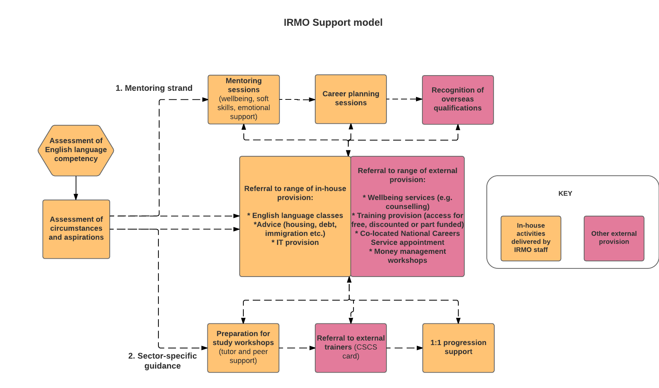
All participants accessed one to one support for an average of 5 hours per participant. A wide range of additional support services were also available, including: a co-located Spanish-speaking National Careers Service adviser who provided careers guidance and job application support; in-house IT provision, English classes and advice; and partnerships with external providers for discounted or free English language training. In total, each participant received an average of 15 hours of support.

Participant characteristics and barriers
Participant characteristics
Of IRMO’s 154 Step Up participants:
- Around two thirds (68%) were male and 32% were female; IRMO were the only provider to have male participants as the majority.
- Participants spanned the age range, but the majority (36%) were aged between 41 and 50. The average age was 41.
- 87% were Latin American and 98% had English as an additional language
- 82% had overseas qualifications, including 28% with an overseas degree
Employment situation
- 40% of participants did not know what their employment contract was. Of those who did know, less than half had a permanent contract: 21% had a zero hours contract, 19% had a temporary contract and 14% had no contract.
- IRMO participants were overwhelmingly employed in the cleaning (57%) or the hospitality (25%) sectors.
- 98% of IRMO participants wanted a career change when they joined Step Up.

Participant barriers to progression included:
- English language capability and confidence. This was a significant and long term barrier. Participants with predominantly Spanish speaking social networks and physically tiring or irregular working hours had limited time and energy to learn English.
- Precarious labour market situations and labour market exploitation, exacerbated by limited English skills.
- Non-transferable qualifications and digital skills barriers.
- Financial difficulties and mental and physical ill health. Individuals with limited English could find it difficult to access wider support services to meet these needs.
- ‘Mindset’ and motivation to progress. Participants who had migrated and experienced a (relative) improvement of their financial situation could have limited motivation to progress further. This could be exacerbated by the experiences of their social networks. Recent political uncertainties following the vote to leave the European Union also resulted in participants feeling less secure in their long term future in Britain, which had a negative impact on their motivation to learn English and progress their careers in the UK.
Outcomes achieved
- 47 participants achieved new qualifications through Step Up and 51 participants achieved an employment related outcome (a third of all those registered).
- Most of these outcomes were new jobs (42 people), while 9 people got an additional job, 6 people improved their contract, 5 people got a promotion and 1 person improved their working hours.
- The average length of time taken to achieve an employment-related outcome was 6.1 months.
The largest positive sector changes were people becoming employed in construction (+19%). The sectors that participants were leaving were cleaning (-16%) and hospitality (-14%).
Programme targets:
- 25% of participants obtained a 10% increase in hourly wage
- 18% of participants obtained an hourly wage of LLW or above
- 18% of participants obtained the weekly earnings target (36 hours x LLW or 18 hrs if lone parent)
- 4% of participants who started on an insecure contract obtained a permanent contract (although there was a shift away from zero hours and people having no employment contract)

Key strengths
- One to one coaching support
This included support with online applications and job search, help to navigate bureaucratic processes, translating paperwork and redesigning CVs and applications. Coaching support was key to improving participants’ confidence and aspirations and providing essential guidance for adjusting to the more formal UK labour market culture.
- Flexible provision
IRMO delivered their provision flexibly to enable working participants to access support. This included group-based construction training at the weekend to fit with participants’ schedules. Their premises were open until 8pm and much of their provision was delivered outside of standard working hours. Mentors could meet their mentees at convenient times.
- Effective recruitment
IRMO were able to recruit easily through word of mouth in their local community. The construction course offer was particularly effective as it presented a tangible outcome and pathway into a popular career field. The construction sector is also relatively attainable for participants with a lower standard of English in comparison to other sectors.
- Range of wider provision
A range of Spanish-speaking support was available for issues such as language support, childcare and immigration issues. English learning was integrated into the support through dual language training provision, a glossary of key construction terms and the requirement to speak English in mentor sessions. Partnerships were built with training providers which supported participants to access training by part-funding courses.

Key learning
- Partnership working
IRMO delivered most elements of its support in Spanish which made it accessible for participants. However this presented difficulties to effective partnership working with English speaking organisations and employers. IRMO managed this by offering a wide range of in house support, but the limited ability to build partnerships resulted in more resource intensive delivery. One particular difficulty was that employers and companies with more relaxed English speaking requirements were less likely to pay the London Living Wage.
- Sustaining engagement
Participants with long working hours, changing work schedules and demanding lives could be waylaid by more immediate challenges. IRMO had a range of wider support, but some needs such as mental health were difficult to address and out of scope for Step Up. IRMO adopted several strategies to sustain engagement including regular communication with participants, introducing a deposit for the training course and setting out a contract of expectations for mentoring.
- Resourcing
Step Up was delivered by several volunteers undertaking key roles such as employment supporters and mentors, with one full time worker delivering the construction course. Volunteers could leave IRMO with little notice and could be difficult to replace.
Case study: Hugo

Hugo has worked as a cleaner since he came to the UK two years ago, but previously worked in construction and as a self-employed electrician in Spain. Hugo heard about Step Up from a work colleague, and through Step Up received support to write an English CV, attended training to attain his construction license and accessed careers guidance.
He now has a UK construction license and has learned that one of his Spanish qualifications can be translated into a UK relevant qualification.
Hugo has decided to stay in his current role because he works mornings so is able to attend English classes in the afternoon. He plans to take a course to make his electrician license valid for working in the UK when he has reached a good enough level of English to confidently undertake the exam. He felt he had gained a valuable support network through IRMO and hopes to volunteer at IRMO in the future to help others:
"I thought I’d just come and they’d help me to get the license and that would be it, they’d forget about me, but I’ve made a really worthwhile connection and I’m hoping that in the future I can help others the same way that people have helped me here." [Translated interview]

The Springboard Charity
The Springboard Charity aims to help young people achieve their potential, and to alleviate poverty by supporting disadvantaged and underprivileged people into sustainable employment within the hospitality, leisure and tourism industries. Activities include: education and learning activities in schools; specialist careers advice and guidance; skills development; preparation for work and pre-employment training; work experience; supporting people into sustainable employment; and mentoring.

Step Up support model
Springboard’s Step-Up project aimed to work with low-paid workers to support them with career progression in the hospitality industry, by overcoming barriers, identifying professional development opportunities, and providing one-to-one mentoring.
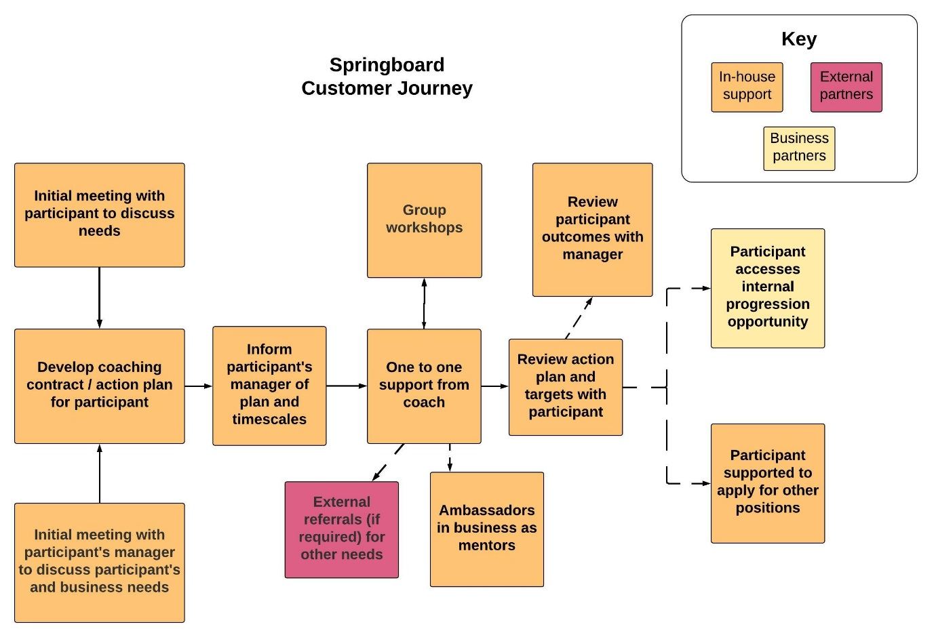
The key elements of the support model, depicted below, included: individual needs assessment; development of an action plan; a combination of group support sessions and one to one coaching; a post-support review and handover to a peer mentor and/or additional IAG and job brokerage support to look for external opportunities.
Springboard recruited two cohorts of participants – the first through one large hospitality employer and the second via direct engagement with individuals in the sector. Support was delivered differently in each case.
Delivery mode: Cohort 1 primarily accessed group support, supplemented by wraparound one to one support to ensure individual barriers were addressed. The group sessions, tailored to industry needs, covered: customer service; confidence & motivation; teamwork & communication; and leadership. Cohort 2, coming from different employers, with different work schedules, received similar content, but this was delivered primarily as one to one support, at flexible times and locations to suit their individual schedules.
Support to realise progression: Cohort 1 mostly aspired to progress within their current business, and were selected for the programme by their employer. At the end of the support they were matched with a peer mentor for ongoing support. Cohort 2 were often looking for other options. Additional IAG and jobs brokerage support was therefore provided via other Springboard services. For both groups, the support was designed as a short intervention (approximately seven months), to give individuals the tools to realise their goals and support their own career development.
All participants attended at least one 1:1 adviser session for an average of 4 hours per participant and received 10 hours of support in total.

Participant characteristics and barriers
Participant characteristics
Of Springboard’s 21 Step Up participants:
- 62% were male, 38% were female.
- Half were aged between 18 and 30, with the remaining participants split across the 31-40, 41-50 and 50+ age brackets.
- Participants were relatively highly qualified: 30% had a UK degree and a further 40% were educated to level 3. Just 5% had no qualifications.
Employment situation:
- A significant majority (76%) had permanent contracts; 19% had a zero hours contract; and 5% had a temporary contract.
- Almost half worked 31-40 hours and almost a third worked 16-24 hours.
Participants were in a range of entry-level roles in the hospitality sector, such as kitchen staff, front-of-house and reception staff. The key barriers they faced were:
- confidence & motivation to take steps towards progression,
- soft skills, such as leadership, and
- ambivalent attitudes towards progression to management roles.
The first cohort of participants were selected by their employer and tended to be committed to the sector and had good customer service skills. The second cohort had further barriers around soft skills and additional needs and barriers such as ESOL and childcare.
Outcomes achieved
- 8 participants achieved an employment related outcome (38% all those registered).
- Most of these outcomes were promotions (5 people), while 2 people got a new job and 1 person improved their contract.
- The average length of time taken to achieve an employment-related outcome was substantially shorter than other providers at 2.9 months.
Programme targets:
- 18% of participants obtained a 10% increase in hourly wage
- 9% of participants obtained an hourly wage of LLW or above
- 23% of participants obtained the weekly earnings target (36 hours x LLW or 18 hrs if lone parent)

Key strengths
- Employer involvement
Uniquely, Springboard engaged low-paid workers via the employer and focused on supporting in-house progression. Employers selected those who had potential but required further support. Involving the line manager in the initial assessment was helpful to uncover barriers that the individual may not have recognised. Employer commitment also facilitated achieving a comparatively high rate of promotions (almost a quarter of all participants).

- Group sessions
Group sessions worked effectively for cohort 1, as, coming from the same employer, they had similar needs, and were given time to attend the programme sessions within work hours by their employer. Participants could reflect on their work experiences and discuss them with others in a similar situation, sharing information and best practice.

- Mentoring
For cohort 1, each participant was matched with a mentor within their organisation, but located at a different branch, which was possible because of the commitment of the employer to the pilot. Mentors who had recent experience of progression were selected so that they were able to support participants with common challenges, such as adapting to changed team dynamics following promotion.

- In-house Careers IAG offer
Cohort 2 had access to an enhanced careers IAG and jobs brokerage offer. This included exclusive access to vacancies from business partners, CV reviews, professional interview coaching and job matching and screening. This enhanced offer was necessary to facilitate outcomes in the absence of active employer engagement.

Key learning
- Engaging employers
Employer engagement on to the programme was an ongoing challenge. Using existing networks of employers with a connection to the provider was effective for initial outreach, but it was difficult to convert this into active engagement.
Engagement needed to be proactive and persistent and the offer of support tailored to employer needs and in alignment with their existing mechanisms and structures for staff development and progression. In short, the offer had to be seen as a tailored business solution rather than a pre-established support offer.
‘Cold calling’ employers proved unproductive. Such employers either felt that the support duplicated their in-house offer, felt unable to release staff for training, or were concerned about the prospect of staff leaving the organisation.
- Communicating the message
It was important to get the Step Up message right for both participants and employers.
- For participants, simple language was required. The term ‘career’ was felt to be off-putting to many, while “do you want to improve your job?” was a message that resonated well.
- For employers, the messaging needed to emphasise the benefits to the employer, in terms of staff loyalty and improved retention.
- Duration and intensity of support
The short-term, and relatively light touch model worked well for cohort 1 who attended a series of group sessions in work time and were then supported by peer mentors in the workplace. For cohort 2, without employer engagement, support was delivered more flexibly, and so was more variable in duration and intensity. This had implications for project resourcing. The timescale was also too short for the achievement of outcomes without employer support. This was addressed through signposting to wider careers support provided by the organisation.
Case study: Mariana

Mariana moved to the UK and secured her current position as a catering assistant 2 years ago. She has a daughter in nursery and is a single mum. She wants to earn enough to provide financial stability for her family but her priority is to work hours that enable her to spend time with her daughter. She heard about Step Up through a letter in the post and was attracted by the possibility of help to find a more suitable job in the catering industry.
She met the adviser monthly, one to one at a nearby location, and completed online professional development activities in-between sessions. Support focused on careers guidance, job search, CV development, better off calculations and training in soft skills, for example team work. Mariana felt that the most valuable aspect of the support was the coaching on how to communicate effectively at work:
"First because I feel more confident in my job, so a lot of people were stressing me in the job, I started all stressed with it. And second is talk - not just thinking, Oh if I talk what will be the reaction of my colleagues, or what will be the reaction of the manager? Talk and I can see the reaction."
This support gave her the confidence to talk to her manager about changing her work schedule so that it better fitted her home life. Support from the adviser also enabled her to assess the relative merit of other jobs available, and encouraged her to seek improvements in her existing job rather than moving to a new position.

Thames Reach
Thames Reach is a not-for-profit organisation based in Peckham, assisting homeless and vulnerable men and women to find decent homes, build supportive relationships and lead fulfilling lives. As well as running three areas of support for homeless and vulnerable people (response, prevention and recovery), Thames Reach provides a variety of employment and skills programmes helping people to find work and access training.

Step Up support model
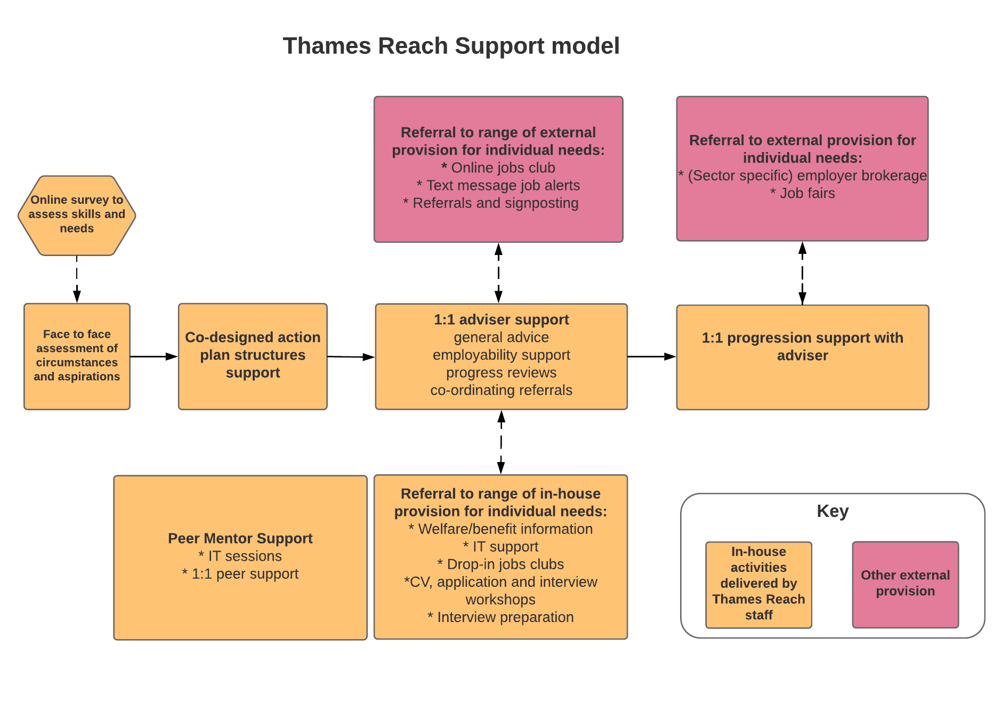
The Thames Reach support model targeted a wide range of low paid workers, delivering one to one adviser support, workshops, peer mentoring and a wider support offer through partnerships. Thames Reach also partnered with Clean Slate to trial digital methods for engaging participants.
Almost all Thames Reach participants accessed one to one support for an average of 5 hours per participant. Large numbers of participants also accessed group-based and employability support. The range of services available included in-house provision, such as IT courses and confidence building workshops, and support delivered by key partners, such as employers and recruitment consultancies who delivered job brokerage and advice sessions. In total, each participant received an average of 14 hours of support.

Participant characteristics and barriers
Participant characteristics
Of Thames Reach’s 96 Step Up participants:
- Two thirds (65%) were female and a third (35%) male.
- The average age was 43, with participants split across the 31-40, 41-50 and 51+ age brackets. Almost a third were aged over 50, the highest across providers.
- The majority had qualifications at level 1, 2 or 3, with only 8% holding a UK degree. 16% had secondary education overseas, while 7% had no qualifications.
- 45% had English as a Second Language.
- Family situations varied: almost two thirds (63%) had no dependent children, while a quarter were lone parents.
Employment situation
- Around three quarters had a permanent contract on joining the programme, while a quarter had a temporary zero hours contract.
- The most common sectors were retail (20%), followed by hospitality (18%), cleaning (17%) and care (16%).
- 71% said changing their career was a priority.
Participant barriers to progression included:
- Lack of qualifications, limited relevant work experience or skills. Having limited basic skills (particularly IT and literacy) was a significant barrier. This was perpetuated for people without access to the internet or a computer at home and people in full-time work with limited time to dedicate to upskilling.
- Limited suitable and secure employment opportunities. This was particularly an issue for lone parents who were often seeking part-time work within walking distance of their homes.
- Interaction of work and benefits. Participants had concerns over how higher pay would affect their benefits which could prevent them from wanting to progress. This was exacerbated due to the roll out of Universal Credit and the changes to entitlements.
- Limited ability in searching for jobs and making good job applications. This was exacerbated for some by limited English skills or other learning needs such as dyslexia.
- ‘Softer’ barriers such as a lack of confidence and motivation.
Outcomes achieved
- 33 participants (around a third of those registered) achieved an employment outcome. Most commonly this was a new job (20 people), while 10 people secured an additional job, 6 improved their contract, 3 were promoted and 1 improved their working hours.
- Participants were most likely to leave hospitality and retail, and moved into a range of other sectors including cleaning, education, health, transport, logistics and other sectors.
Programme targets:
- 19% of participants obtained a 10% increase in hourly wage
- 12% of participants obtained an hourly wage of LLW or above
- 14% of participants obtained the weekly earnings target (36 hours x LLW or 18 hrs if lone parent)
- 24% of participants who started on an insecure contract obtained a permanent contract

Key strengths
- Partnerships
Thames Reach built on existing partnerships to strengthen their support offer. For example, the recruitment consultants, Prospectus, delivered group workshops to clients on entering particular sectors as well as tailored one to one sessions; KPMG provided employability support (CV writing and interview techniques); and an online accredited training provider gave participants access to high quality, flexible courses.
- One to one coaching support
This included support with online job search, applications and interviews, support negotiating contracts and pay, job brokerage and support with bureaucratic processes. Building a trusting relationship with their adviser was key to building participants’ confidence and overcoming individual barriers, as it enabled them to share their issues, concerns and aspirations more easily.
- Flexibly delivered support, tailored to their individual needs
Flexible support was delivered to suit working participants, especially those with irregular or long working hours or childcare responsibilities, including evening workshops and communications via text and email, so that participants could check their phones at work and respond when it was convenient for them.
- Effective recruitment
Thames Reach were able to recruit internally from existing participants of other services offered, for example their information, advice and guidance services. Externally, they worked closely with several providers supporting those at high-risk of homelessness and made a concerted effort to engage with Jobcentre Plus for referrals.
- Peer mentors
Peer mentors performed a paid role supporting Step Up participants, providing employability advice, keeping in touch with participants, and signposting to relevant training or voluntary opportunities. This was highly valued when the mentor had faced similar circumstances and could offer first hand insight into challenges, such as adjusting to UK work culture or sector-specific knowledge. Participants gained soft outcomes, such as increased confidence and motivation which sustained their engagement.

Key learning
- Online registration
Thames Reach partnered with Clean Slate to test digital engagement. The aim was for participants to document their current situation and aims online, and access a member’s network that included a jobs board and event notifications. However, due to a low level of digital skills, the majority of participants required support to complete the online registration process effectively, which proved to be time intensive for staff. Also, the digital registration process did not always identify needs effectively. The online jobs board worked well, however, when combined with a text to encourage members to apply for new vacancies. 50% of participants who clicked through to the jobs board completed applications.
- Working with recruitment agencies
Thames Reach found that they were unable to meet their clients’ broad range of needs and aspirations through engaging with employers individually, and found it more effective to work with recruitment agencies who could place participants into appropriate roles. This saved provider time and resource that could instead be spent on one-to-one coaching support. One of the agencies they partnered with focused on recruiting for the non-profit sector, where there was a greater commitment to the Living Wage.
- Monitoring engagement
Working participants with busy schedules and wider responsibilities or needs could often disengage from support. Regular contact with participants was key to sustaining engagement. Through texts and email bulletins, staff could identify which participants were engaging and those who were not. Peer mentors would then check in with the latter group to get them re-engaged.
Case study: Peter
Peter, an IT professional originally from Eastern Europe, found out about Step Up when he saw an advert his local Jobcentre Plus. He had recently moved to London, and was working part-time at a high street fast food chain, but wanted to progress into a role that aligned with his educational background and career goals.
As well as attending group interview practice and receiving regular job alerts, the one-to-one support from his adviser was what Peter valued the most. In these sessions, he developed an action plan, re-wrote his CV, and completed job searches and applications.
Through Step Up, Peter secured a new permanent position in IT, which constituted a considerable earnings increase and boosted his confidence. He felt that the support offer was tailored to his needs and attributes his success to his adviser who he felt went above and beyond expectations to support him:
"What really amazed me, … she has gone that extra mile...I think she has done her homework somehow and, from that point, basically she became such a professional in IT jobs that there are no words to describe it. She just sent over this one, this one, this one and they were all just for me… [my adviser] has provided over my expectations."

Women Like Us
Women Like Us is a social business operating in Lambeth, Hackney and Camden that works to build a better future for women who want to carry on working after they have had children. Their objective is to give women the choice to fit work around the needs of their family without losing their value in the workplace. Women Like Us is part of the Timewise Foundation, which seeks to build a quality part time and flexible jobs market as a way to tackle gender inequality, maternal unemployment, and child and family poverty.

Step Up support model
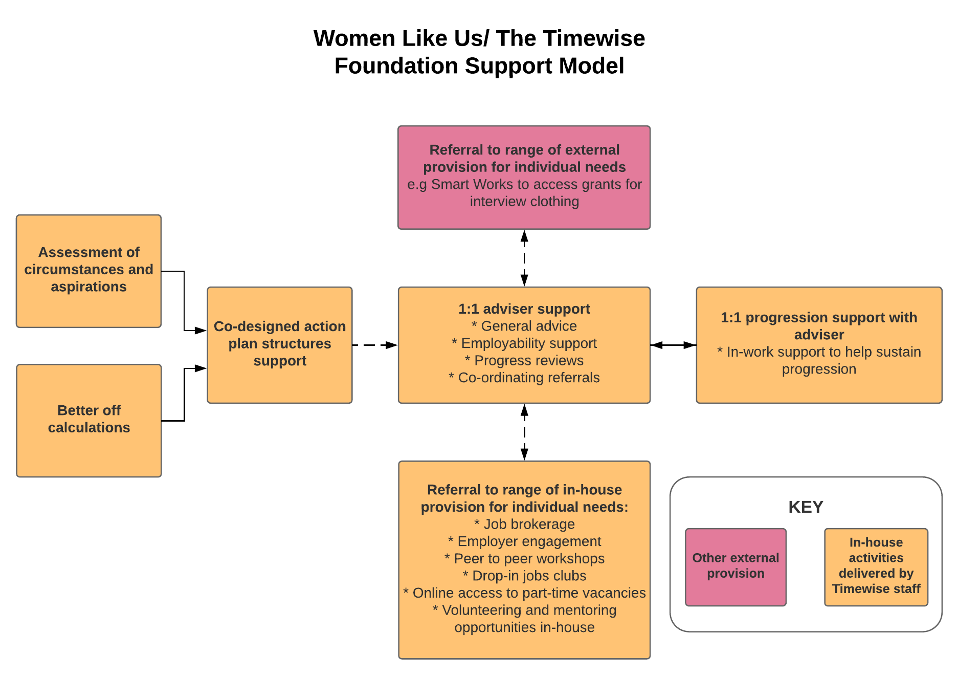
The Step Up model focused on supporting parents working in low income jobs to move into better quality work. This entailed building skills and confidence through employability support and career coaching, and supporting participants into quality part time and flexible jobs generated by working with employers to champion the social and business benefits of flexible working.

All participants accessed one to one support for an average of 4 hours per participant. The overwhelming majority of participants also accessed in-house employability support, including drop-in CV sessions, and could be signposted to partners such as Smart Works to access grants for interview clothing. Over eight in ten participants also accessed Timewise’s specialist job brokerage support. Participants received an average of 7 hours of support in total.

Participant characteristics and barriers
Participant characteristics
Of the 140 Step Up participants with Women Like Us:
- 94% were female.
- The average age of participants was 42, with two thirds of participants aged between 31 and 50.
- Participants had a wide range of qualification levels: 18% had qualifications at level 2, 17% had level 3 and 18% had a UK degree, while a further 16% had an overseas degree. One in ten participants had no qualifications.
- 95% of participants had children and around two thirds were lone parents. Children tended to be primary-school aged or below.
- Just over half of participants (56%) spoke English as an additional language.
Employment situation
- Over 8 in 10 participants had a permanent contract when they started the programme, while 13% had temporary contracts.
- Just over half of participants worked part-time (16-24 hours per week), while a quarter worked between 31 and 40 hours.
- Participants worked primarily in one of four sectors: 20% in retail, 19% in cleaning, 19% in health and 17% in administration.
- 79% wanted to change their career as one of their key aims when joining Step Up.
Participant barriers to progression included:
- Childcare responsibilities. This was a significant factor which limited participants’ time and ability to find suitable roles. For participants who had a lack of familial support, the high cost of childcare could prevent them from engaging with support, working additional hours or taking on more responsibility.
- Lack of access to local, part time, flexible jobs. This was a particular challenge for parents who did not want to, or who felt they could not afford to, use formal childcare outside of school hours.
- Navigating the jobs market. Participants who wanted to secure higher earnings through getting a new job often lacked an up-to-date and well-structured CV or interview skills.
- Softer barriers, including confidence and self-esteem. These barriers were particularly significant for those who had experienced setbacks previously, during recruitment processes or in work.
Outcomes achieved
- 37 participants (around a quarter of all those enrolled) achieved an employment-related outcome. Most of these (26 people) secured a new job, while 8 people took on an additional job, 3 people secured a promotion within their current work, and 2 people improved their working hours.
- Participants were most likely to leave the cleaning and retail sectors and most likely to move into administration or social care.
- Those working a smaller number of hours (0-15) were more likely to achieve employment outcomes, while those working full time (31-40 hours) were less likely
Programme targets
- 11% of participants obtained a 10% increase in their hourly wage
- 15% of participants obtained an hourly wage at the level of the London Living Wage (LLW) or above
- 19% of participants obtained the weekly earnings target (36 hours x LLW or 18 hours if a lone parent)
- 26% of participants who started on an insecure contract obtained a permanent contract

Key strengths
- One to one, tailored and flexible support
Participants were able to develop a close, trusting relationship with their adviser, which boosted their confidence and motivated participants to sustain their engagement. Support was delivered flexibly to suit working parents’ availability, including sessions in the evening and phone/email support.
- Effective recruitment
A “no wrong doors” approach to recruitment was adopted, which ensured that anyone who came in contact with the organisation would be informed about Step Up if it was relevant to them. They also used Parent Ambassadors who had secured outcomes to tell their wider networks about the service.
- Employer links
The support was designed to enable working parents to access jobs that could accommodate their needs, drawing on Timewise’s wider employer engagement activity. This entailed ‘reverse marketing’ of participants to employers: putting forward high quality candidates encouraged employers to make the roles available on a part-time, job-share or flexible basis, in order to get the right person for the job. This worked particularly well with SMEs.
A successful relationship was also established with an NHS Foundation Trust: support was delivered to the Trust’s employees to enable them to upskill and make better use of internal progression routes. Step Up participants were also given the opportunity to complete an online test to enter the Trust’s pool of candidates for internal vacancies. This helped to engage potential participants on to Step Up.

Key learning
- Resourcing
The requirement for one-to-one, tailored support imposed a burden on staff resource, and this needed to be balanced with time spent on engagement and recruitment activity, data recording for the purposes of monitoring and evaluation, as well as practicalities, such as sourcing suitable locations for evening sessions.
- Recruitment
Potential participants with secondary school aged children were found to be harder to recruit, partly due to fewer opportunities for face-to-face engagement ‘at the school gate’. To reach this group, it was necessary to get buy-in from the schools in order to plan recruitment events. Recruiting through Housing Associations also elicited a limited response, which may have been because tenants were suspicious of receiving this information from their landlord.
- Marketing
It was found to be most effective to focus the messaging for Step Up on a tangible outcome, i.e. the types of jobs on offer, rather than the support provided. A leaflet design showing a pin board with various job opportunities and salaries was found to convey an effective, outcome-based message, which stimulated recruitment, since it enabled potential participants to see how they might achieve their goals.
- Working with employers
Working with employers to upskill staff internally raised key challenges such as convincing employers that it would not result in them losing staff. In engaging with employers, it was important to align the support offer with the business’s corporate structure and agenda, and to identify the right person to engage with, so that the message could be effectively embedded through the organisation.
Case study: Aisha
Aisha had a degree qualification and extensive experience in the charity sector when she engaged with Step Up, having seen a leaflet in her local library. She was looking to move out of her role, which did not provide her with security, but felt that she needed support to do so.
She found the support through Step Up extremely useful, particularly:
- group sessions, because this provided an opportunity to meet other lone parents in a similar situation,
- support in updating and improving her CV, because this helped her to secure a new role, and
- personalised and tailored face to face support because this boosted her confidence.
Aisha succeeded in securing a new job, and although her hourly pay did not notably increase, she finds the new position more “rewarding and fulfilling”, which not only offers her room for progression and training opportunities, but is also flexible to accommodate her childcare responsibilities and is within walking distance of her home which has reduced her travel costs and time. This change has had a tangible positive impact on her overall health and wellbeing:
"My general health and wellbeing has certainly improved...Now that I’m actually in the job I think that all those aspects have really, really improved, I’m certainly sleeping a lot better…I’m just a lot more happier”

These figures are averaged across everyone who had at least 1 one to one session. In practice some people had much more intensive support while others disengaged relatively quickly.
These figures are averaged across everyone who had at least 1 one to one session. In practice some people had much more intensive support while others disengaged relatively quickly.
These figures are averaged across everyone who had at least 1 one to one session. In practice some people had much more intensive support while others disengaged relatively quickly.
This project only delivered for 18 months of Step Up
These figures are averaged across everyone who had at least 1 one to one session. In practice some people had much more intensive support while others disengaged relatively quickly.
These figures are averaged across everyone who had at least 1 one to one session. In practice some people had much more intensive support while others disengaged relatively quickly.
These figures are averaged across everyone who had at least 1 one to one session. In practice some people had much more intensive support while others disengaged relatively quickly.

